**Project Design Phase-II**

**Technology Stack (Architecture & Stack)**

|  |  |
| --- | --- |
| Date | 21 October 2022 |
| Team ID | PNT2022TMID03512 |
| Project Name | Project - Real-Time Communication System Powered by AI for Specially Abled |
| Maximum Marks | 4 Marks |

**Technical Architecture:**

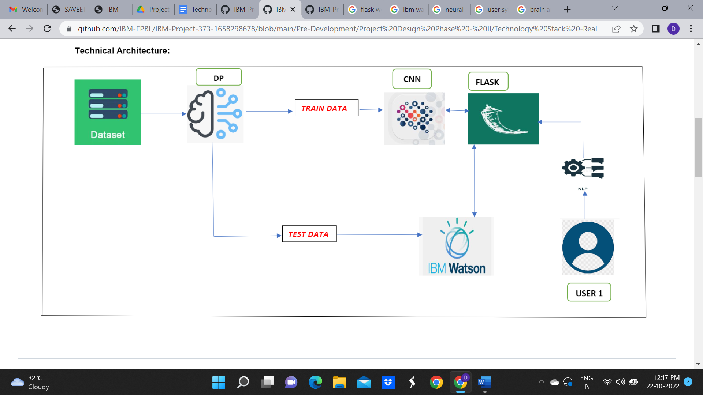

**Table-1 : Components & Technologies:**

|  |  |  |  |
| --- | --- | --- | --- |
| **S.No** | **Component** | **Description** | **Technology** |
|  | User Interface | The application can be accessed using Web UI and mobile application for the user to interact | HTML, CSS, Python |
|  | Application Logic-1 | Capturing and storing the sign language images as dataset | Python |
|  | Application Logic-2 | Analysing the sign language pictures and represent the hand gestures | IBM Watson, Python, CNN |
|  | Application Logic-3 | The input data is given by getting audio | IBM Watson, Python, CNN |
|  | Database | Pictures of the sign language gestures and their description | MySQL, JavaScript, IBM DB2 |
|  | Cloud Database | Database Service on Cloud | IBM DB2, IBM Cloudant etc. |
|  | File Storage | The sign language pictures and the input audio clips are stored in the cloud | IBM Block Storage, IBM cloud, Local Storage |
|  | CNN – Convolutional Neural Network | Purpose of CNN is to decode the sign language into the readable language and vice-versa | CNN, Object detection model, NLP |
|  | Machine Learning Model | Purpose of AI-Machine Learning Model is used to recognise the hand gestures, sign language and vice-versa | Object Recognition Model, CNN and NLP for voice data and hand gestures |
|  | Infrastructure (Server / Cloud) | We will deploy the AI and CNN model using flask in the web application of cloud server | Python flask |

**Table-2: Application Characteristics:**

| **S.No** | **Characteristics** | **Description** | **Technology** |
| --- | --- | --- | --- |
|  | Open-Source Frameworks | Open-Source framework used in IBM Watson | Technology of Opensource framework |
|  | Security Implementations | IBM cloud | IAM Controls, OWASP |
|  | Scalable Architecture | Database Server- On the basis of new applications acquiring from the user, the dataset can be modified accordingly.  Application Server- While updating of dataset takes the integration of the application as per user demands and requirements can be done. | IBM Watson Assistant, MySQL, Python |
|  | Availability | The AI and CNN model is available instantly when in need without any modifications process can be made | IBM Watson Cloud Assistant |
|  | Performance | IBM Watson and the cloud is used to store data where the deep learning and NLP model is used for training of hand gestures(data). By using IBM Watson studio better performance and convenience. | IBM Watson Assistant, NLP |